## Activity 1

**My Journey Within – A Self-Exploration Journal**

### Overview of the My Journey Within

Text

### Introduction About Activity

Text

A reflective article

### Description:

Text

**My reflection of creativity**   
Use <https://magma.com/> to build visuals.

OR

## Group Activity

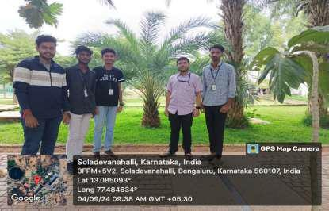

Fig 1.0: About activity in picture

## Activity 2

**My Journey Within – A Self-Exploration Journal**

### Overview of the My Journey Within

Text

### Introduction About Activity

Text

A reflective article

### Description:

Text

**My reflection of creativity**   
Use <https://magma.com/> to build visuals.

OR

## Group Activity



Fig 1.0: About activity in picture